**SAMPLE SHEET (FRONT PAGE)**

**PROJECT TITLE**

**BCA Semester VI PROJECT PHASE - II REPORT**

**(PROJECT PHASE I & II COMBINED: CONTINUES)**

SUBMITTED IN PARTIAL FULFILLMENT OF THE REQUIREMENTS

FOR THE TERM WORK OF SEMESTER-VI

**BACHELOR OF COMPUTER APPLICATIONS**

**SUBMITTED TO**



**A constituent college of**

**KADI SARVA VISHWAVIDYALAYA**



**SUBMITTED BY**

Name of Student(s) (14pt) University Exam No(s). (14pt)

NIKHIL BHIKANBHAI PATIL 231

AKASH ARVINDBHAI SUTHAR 232

SHRADHAY RAJ 233

**Name of the Company** (E-CONSTRUCTION)

2021 (12pt)

(March & 2021 Year of Submission)

|  |  |
| --- | --- |
| C:\Users\vishal\AppData\Local\Microsoft\Windows\INetCache\Content.Word\BPCCS-LOGO.PNG | **B. P. College of Computer Studies**  **A Constituent College of KADI SARVA VISHWAVIDYALAYA** |

**CERTIFICATE FROM DIRECTOR**

This is to certify that the project documentation entitled ‘E-CONSTRUCTION’ is bonafide project work done by‘NIKHIL BHIKANBHAI PATIL,AKASH ARVINDBHAI SUTHAR ,SHRADHAY RAJ’ in partial fulfillment of the requirement for the award of degree of Bachelor of Computer Application at B. P. College of Computer Studies – a Constituent college of KADI SARVA VISHWAVIDYALAYA.

Date : ______________ _____________

Director

|  |  |
| --- | --- |
| C:\Users\vishal\AppData\Local\Microsoft\Windows\INetCache\Content.Word\BPCCS-LOGO.PNG | **B. P. College of Computer Studies**  **A Constituent College of KADI SARVA VISHWAVIDYALAYA** |

**CERTIFICATE FROM INTERNAL GUIDE**

This is to certify that the project report compiled by Mr./Ms. NIKHIL BHIKANBHAI PATIL,AKASH ARVINDBHAI SUTHAR,SHRADHAY RAJ student of semester – VI of BCA, B. P. College of Computer Studies, a Constituent College of KADI SARVA VISHWAVIDYALAYA, Gandhinagar is done under our guidance. To the best of our knowledge, the work is done satisfactorily. During the tenure, they were found hard working and sincere. They completed all the tasks assigned and suggested to them.

Comments:

1.

2.

3.

_________________

Internal Guide

**Index with Project Phase – I**

**Paste here**

**Chapter Page No.**

1. **TECHNOLOGY & PLATEFORM** 
   1. TITLE OF THE PROJECT
   2. OVER VIEW OF TECHNOLOGY / PLATEFORM
   3. FUTURE ENHANCEMENT OF TECHNOLOGY / PLATEFORM
2. **COMPANY OVERVIEW** 
   1. NAME & CONTACT DETAILS OF COMPANY / INSTITUTE
   2. HISTROY OF COMPANY / INSTITUTE
   3. GROWTH OF COMPANY / INSTITUTE   
      ( IN FIGURE OF SALES OR TRANSACTION )
3. **STUDY OF EXISTING SYSTEM** 
   1. CURRENT WORKING METHOD OF SYSTEM [diagram]
   2. EXISITING SYSTEM FLOW
   3. DRAWBACK OF EXISITING SYSTEM.

**4. PROPOSED SYSTEM**

4.1 PROPOSED SYSTEM TYPE

4.2 PROPOSED SYSTEM FLOW [diagram]

4.3 MODULE OF PROJECT

* 1. ADVANTAGES OF PROPOSED SYSTEM

**5. FEASIBILITY STUDY**

5.1 OPERATIONAL FESIBILITY STUDY

5.2 TECHNICAL FEASIBILITY STUDY / SRS

5.3 ECONOMICAL FEASIBILITY STUDY (including Tangible and Intangible benefit)

* 1. SCHEDULE FEASIBLITY STUDY

**6 SYSTEM ANALYSIS & DESIGN**

* 1. DFDs ( context level , 0 level , 1st level , 2nd level, 3rd level (if possible))
  2. UML / CLASS diagram [ if applicable ]
  3. E-R Diagram
  4. Data Dictionary

<< PROJECT PHASE – I COMPETE HERE >>

**Index with Project Phase – II**

**Chapter Page No.**

1. **SYSTEM IMPLEMENTATION AND DESIGN**

7.1 SYSTEM DESIGNS OF AUTHENTICATION: SIGNUP & LOGIN FORM (SCREENS)

7.2 SIGNUP & LOGIN FORM

7.3 SYSTEM ADMINSTRATION DESIGNS: TRANSACTIONS, SEARCHING

7.4 SYSTEM REPORTS AS ADMIN LEVEL - CUSTOMER LEVEL - OTHER REPORT AS PER NEED

7.5 SYSTEM VALIDATIONS: VALIDATIONS FOR VARIOUS LEVEL (ADMIN , MANAGER , CLIENTS ...ETC)

7.6 MISC. FEATURES LIKE CAPTCHA SENDING SMS, MAILIG, BILLING, OTP, .... ETC IN PROJECT

1. **TECHNOLOGY & PLATEFORM** 
   1. TITLE OF THE PROJECT

**E-Construction Services.**

* 1. OVER VIEW OF TECHNOLOGY / PLATEFORM

The project is a online platform where project’s motive is to provide construction related services such as construction vehicle & The projects provide these vehicles on rent according to the work.

1.3 FUTURE ENHANCEMENT OF TECHNOLOGY / PLATEFORM

* The project’s main objective is to provide construction related vehicles on affordable rent in rural and urban areas.
* The system provide Heavy duty vehicle like Backhoe Loader, Crane, Bulldozer, Driller, etc…
* In future our goal is to give our services in whole country.
* The technology is used to creating web site and the front end and back en are as follows
* Front end

PHP 7.2.27 version

* Back End

MySQL 2.4.41 version

1. **COMPANY OVERVIEW** 
   1. NAME & CONTACT DETAILS OF COMPANY

E-construction Services

Bhavana Colony,Bapunager,Ahmedabad.

Contact No. 886621909,9104613250,8866214646

2.2 HISTROY OF COMPANY / INSTITUTE

The company is started as new startup since 2020 in covid 19 lockdown.

* 1. GROWTH OF COMPANY

It is new startup so it do not have growth or service figure ….

We apologize

1. **STUDY OF EXISTING SYSTEM** 
   1. CURRENT WORKING SYSTEM

The online platform will provide construction related equipments and construction related vehicles on rental services.

The online platform will provide services to end user.



[www.equipmentrentalsindia.com](https://www.equipmentrentalsindia.com)

Equipment Rentals India (ERI) Found By Mr. Puneet Chadha in year 2009 incorporated as a company in 2011.

Mr. Puneet started his career with Greaves Cotton Ltd and has worked with companies like ICICI Bank Ltd,

Equipment Rentals India (ERI) is a unit of Clicks & Sales Pvt Ltd.

Clicks & Sales Pvt Ltd. has been a pioneer and web and digital technologies.

Equipment Rentals India(ERI) has offices in New Delhi, Bangalore, Chennai and Mumbai.

3.2 DRAWBACK OF EXISITING SYSTEM.

* The platform will providing services only in metro cities.
* The platform is not providing services on reasonable cost.
* Platform take additional charges according to work with additional hours.
* Platform will not give any surety to client if equipment will fail on working site so client will face problem.
* They will provide not exact location of machine or equipment.

**4. PROPOSED SYSTEM**

4.1 PROPOSED SYSTEM TYPE

* The project is a online platform where project’s motive is To provide construction related services such as construction vehicle.
* The system provide Heavy duty vehicle like Backhoe Loader, crane. Bulldozer, Boom lift, Excavator, skid Steer Loader, Driller etc….
* The system provide hourly or daily bases vehicle on rentals.
* The system provides good accountability To consumers.
  1. Proposed System Flow

Client’s Registration

**Feedback**

Billing Section

Booking

Dashboard

Login

4.3 MODULE OF PROJECT Client’s Registration

1. **Client’s Registrartion**

Input :-

* Client’s details Such as Name, Age, Gender, Permanent address, Gov. ID prof. (aadhar or Voter Id for address verification, Place of work).
* Creating Username and Password.

Process :-

* Fetching details from Client and fill it up in system’s form.
* Creating Profile of client.
* Regular Data Sync of Client’s on its work.

Output :-

* Making Profile of its Work
* Permanent Registration of client.

1. **Login**

Input :-

Username and password filled by client in section.

Process :-

* Username it maybe client’s registered email,
* Specified username such as YTraj9089, ThaKash879 or RoylPatil007.
* Password is maybe a combination of Uppercase, Lowercase, Special character case, Numeric type.

Output :-

* Now the result of login page.
* Filling username in section of username block.
* Filling Password in section of Password block.

**3.Dashboard**

Input :-

* Now page will show the dashboard of client’s profile in that section this will shows the information of client such as Address, Gender, Location (it may be real time or last) document which he uploaded. It is editable.

Process:-

* Logged in system
* System shows descriptive format of client’s profile.
* Information will be edited by only client.

Output:-

* Main Menu with with descriptive format.
* Sequential format

**4.Booking**

Input :-

* Selecting Services according client’s requirement.
* Takes Request from selected services from service page according to client.

Process :-

* Takes requests from service page of selected services
* Process the request and convert into Booking by searching or finding the vehicle by system in the client’s required area.
* Once system finds the vehicle or service, System will create a unique Booking id number and apply to client.
* Request passes to Tracking page.

Output :-

* Page shows the descriptive format of Booking . Such as Unique Booking id, working place, Machine owner’s contact details.

**5.Billing Section**

Input :-

* Once Work will be done, A request come from Tracking page,
* On that request the Bill will be Generated respectively.

Process :-

* Requests give command to system that Calculate the amount according to the working hour of machine or Construction vehicle.
* Now will be calculate according on client’s unique Booking id number, exact amount of working hours, working place, Hiring time, Machine Service charge etc.
* Once all calculation will be done then the bill will be given to client’s mail and on its whatsapp number as pdf format.
* Payment will be accepted as online Such As RTGS/NEFT, Online payment method like paytm, phonepay, mobikwik, BHIM UPI.
* If client wants to pay cash so he can pay to our person it maybe Machine Operator or cash collector this person send from project’s headoffice.

Output :-

* Now bill will be generated by system according to system’s calculation and provided to Client’s email and whatsapp number then pay via Online platform or Bank transfer.

**6.Feedback**

Input :-

* Giving rating according to our work via Client rating mail.
* Giving client’s suggestion section via suggestion support mail.

Process :-

* Once payment done by client the system will send a Client rating mail and Suggestion mail to client’s mail and whatsapp number.

Output :-

Page’s main functionality is feedback mail and suggestion mail will be sent to client’s registered mail and whatsapp number

4.4 ADVANTAGES OF PROPOSED SYSTEM

* It is the easy To give a service of JCB, Crane, Boom Lift etc…
* E-construction side using easy and very fast give the services.
* E-construction side do used save a client time.
* E-construction side try To a satisfied Clients.
* E-construction provide employment in rural and urban areas

**5.FEASIBILITY STUDY**

Feasibility study is carried out based on many purposes To analyze whether software product will be right in terms of development, implantation, contribution of project To the organization etc.

**5.1** **OPERATIONAL FESIBILITY STUDY**

1. User friendly Web UI:- The project is belongs To services of construction vehicals so our team makes it easy access of client.
2. Minimum data usage:- Main motive is To provide services on any connection which will be work in remote areas such as 2G .
3. Maximize system connectivity:- Basically In construction area connectivity is not quite good so we need To provide Services in each and every remote area where these machines get into demanded
4. Mobility of Services To Client:- we provide services according To their work.and According To their location.
5. Optimized Setps of system:- In our system the steps of consuming services were quite less .
   1. **TECHNICAL FEASIBILITY STUDY / SRS**

|  |  |  |
| --- | --- | --- |
| **Client**  **Minimum or Highest** | **Server**  **Minimum or Highest** | **Developer**  **Minimum or Highest** |
| **Hardware-**   1. **Processor- 1GHz Highest** 2. **RAM- 512MB or Highest** 3. **Hard Disk- 64 GB or Highest** | **Hardware**   1. **Processor- 1.8GHz or Highest** 2. **RAM- 1.75GB×4 or Highest** 3. **Hard Disk- 500 GB or Highest** | **Hardware**   1. **Processor -2.0 GHz or Highest** 2. **RAM-2.00GB or Highest** 3. **Hard Disk-500 GB or Highest** |
| **Software**   1. **Operating Software-Windows Xp To Windows 10,Android2.3.6 or Latest** 2. **Bit- 32bit To 128bit** 3. **Open Source application softwares such as Google Chrome,Internet explorer,Safari,Mozila Firefox or latest.** | **Software**   1. **Operating system- Windows server 2008 or Latest** 2. **Supported Database- Microsoft MySQL 2005 or Latest.** | **Software**   1. **Operating system-Windows XP To Latest Windows.** 2. **Application Software- Firefox ,Google Chrome** 3. **Codeing Language Front End- HTML-- PHP 4.01 or minimum** 4. **Back end- MySQL** |

1.Ease To access:- In that project's technology which is used for making User adaptive .

2.Developed System Language:- In The Project this will using the latest technical language Front End and Back End such as PHP and MySQL.

1. Machine Management:- Our project will manage by it's own like we say as artificial intelligence.
2. Site Maintenance:- The project needs every certain time,Site's server needs maintenance.
3. Using Open Source platform:-For accessing Our platform consumer needs open source platform application ssuch as Opera,Safari, Mozila Firefox Internet explorer Google Chrome etc.
   1. **ECONOMICAL FEASIBILITY STUDY (including Tangible and Intangible benefit)**
4. Generate Employment:-This project will generate employment according To work place or in Field work .
5. Financial plan:- It is medium term planning approximately it's more than 1 year but less than 5 year and this will plan accordingly market situation.
6. Ease of invest:-For invest in project we will organise bidding system but this will also derived according To situation of market.
7. Credibility:- Helping decision-makers determine the positive economic benefits To the organization that the proposed project will provide.
8. Optimized risk:-Our business belongs To service secTor so this is also a positive point for project.

|  |  |  |
| --- | --- | --- |
| **Task** | **Title** | **Duration** |
| Week 1 | * Project Title * Project Definition * Project Scope/Objective * Technology Using in Creating Project | 07-08-2020 To 22-08-2020 |
| Week 2 | * Study of Existing System * Advantages and Disadvantages * Operational , Technical & Informational Level Problems | 24-08-2020 To 29-08-2020 |
| Week 3 | * Proposed System * Advantages And Disadvantages * SRS including Functional Requirement And Non-Functional Requirement * Feasibility Study | 31-08-2020 To 10-09-2020 |
| Week 4 | * Proposed System Modules * Context , First & Second Level DFD | 11-09-2020 To 22-09-2020 |
| Week 5 | * E-R Diagram | 23-09-2020 To 30-09-2020 |
| Week 6 | * Data Directory | 01-10-2020 To 10-10-2020 |

**6. SYSTEM ANALYSIS & DESIGN**

6.1DFDs ( context level , 0 level , 1st level , 2nd level, 3rd level (if possible)) 







6.2 **E-R Diagram**

**6.3 Data Dictionary**





1. **SYSTEM IMPLEMENTATION AND DESIGN** 
   1. SYSTEM DESIGNS OF AUTHENTICATION: SIGNUP & LOGIN FORM (SCREENS) 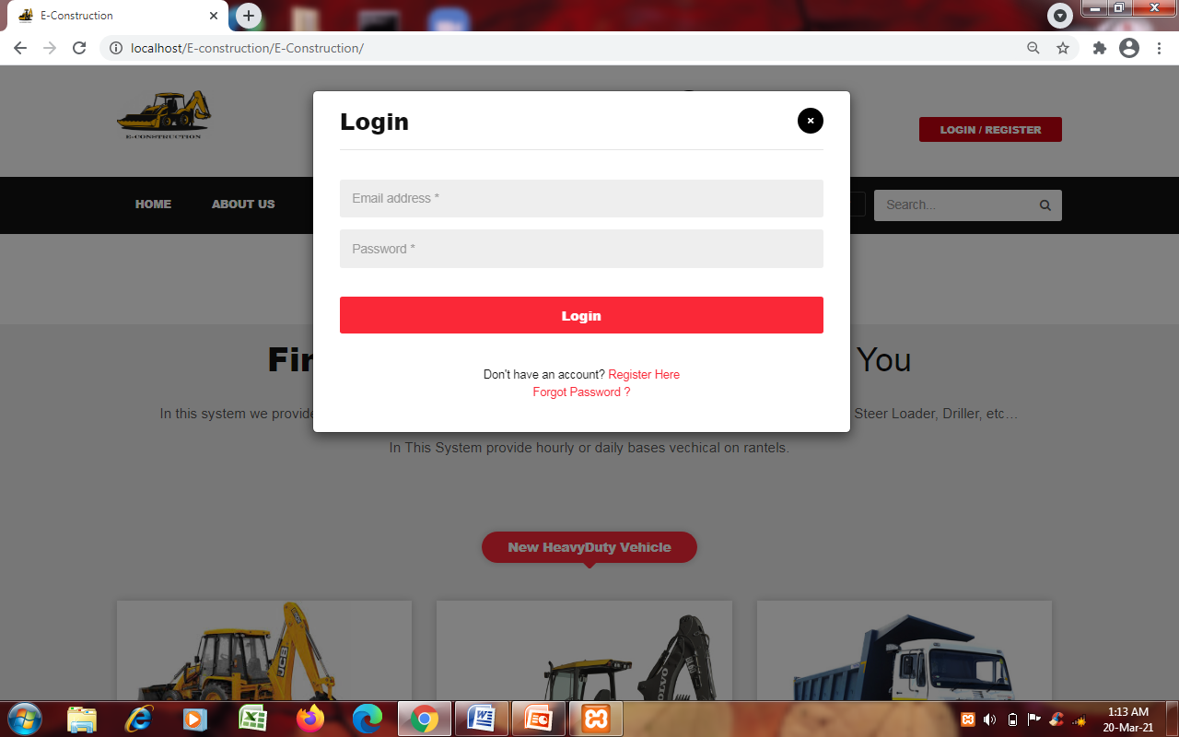

Login Form

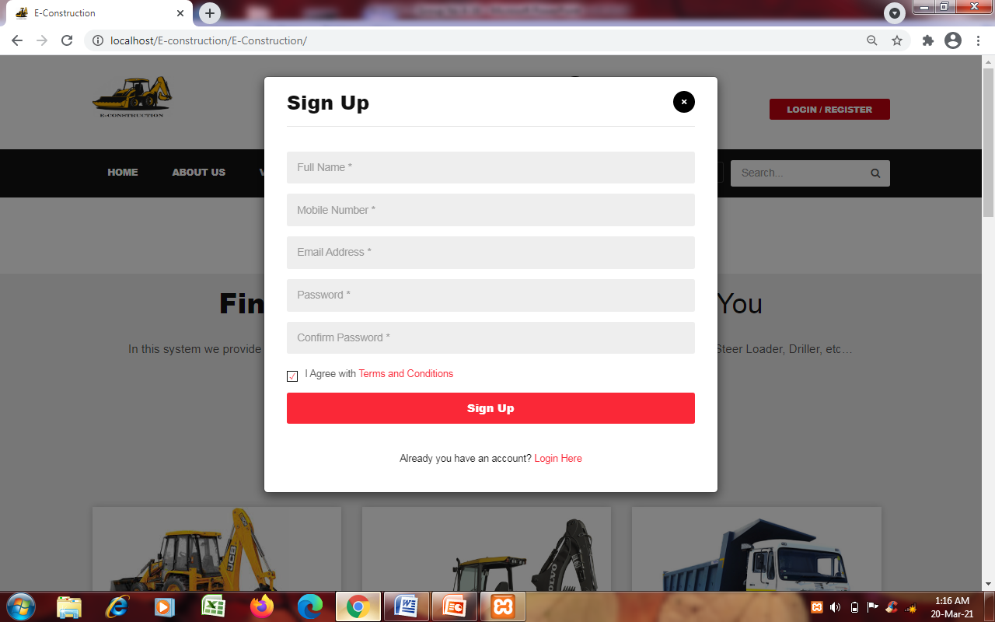& Sign Up form Screen

7.3SYSTEM ADMINSTRATION DESIGNS: TRANSACTIONS, SEARCHING 

* 1. SYSTEM REPORTS AS ADMIN LEVEL - CUSTOMER LEVEL - OTHER REPORT AS PER NEED

7.5 SYSTEM VALIDATIONS: VALIDATIONS FOR VARIOUS LEVEL (ADMIN , MANAGER , CLIENTS ...ETC)

7.6 MISC. FEATURES LIKE CAPTCHA SENDING SMS, MAILIG, BILLING, OTP, .... ETC IN PROJECT